Lab 6 Pseudocode

8.5 (add two matrices)

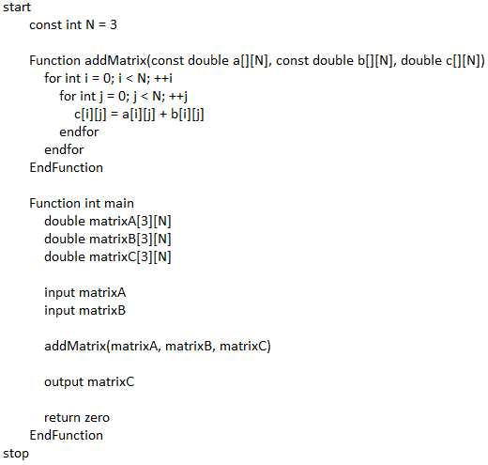

8.11 (nine heads and tails)

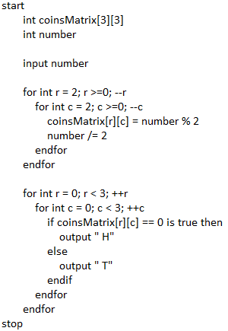

8.15 (guess capitals)

